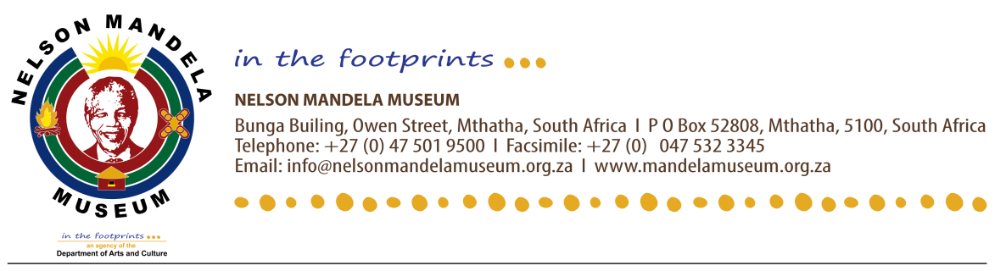
DEAR VALUED GUEST / CLIENT

KINDLY BE INFORMED THAT FROM THE 03RD TO THE 06TH OF APRIL 2026, NELSON MANDELA MUSEUM WILL BE CLOSED. THIS IS DUE TO THE ANNUAL EASTER HOLIDAYS. THE NELSON MANDELA MUSEUM WISHES ALL ITS CLIENTS A WONDERFUL EASTER WEEKEND.
WE FURTHER APOLOGISE FOR THE INCONVENIENCE THIS MAY CAUSE.

FROM NELSON MANDELA MUSEUM MANAGEMENT

